MOSITURE METER
MT-918 USER MANUAL

1. SAFETY
Read the following safety information carefully before attempting to operate or service the meter. Use the meter only as specified in this manual; otherwise, the readings provided by the meter may be impaired.
◆ Working environment conditions：
    - Operating Temperature: 2）Operating Humidity: 0%~85%
0°C~50°C/32°F~122°F
◆ Maintenance:
- Periodically wipe the body with a dry cloth. Do not use abrasives or solvents.
- Do not store it in the following environments:
- near water or dusty areas
- areas of high salinity, sulfur or other chemical substances high temperature and high humidity
2. APPLICATION
This moisture meter is designed for testing moisture levels in wood and aggregate building materials. Combining the micro controller technology and integrated characteristics for 4 material groups increases the accuracy of measurement. It is widely used for measuring the moisture level in the in the professional environment.

3. FEATURES
- Use on woods, bamboo, paper, wood fiber articles and aggregate building materials
- Large color LCD display
- Replaceable electrode pins
- Simultaneous measurement and display of moisture & temperature readings
- Materials selection measurements
- Moisture level indication by tricolor LED bar graph
- With Flashlight
- MAX/ DATA Hold
- Auto power off
4. SPECIFICATION
Electrode length | 10mm (replaceable)
Moisture Range | Wood：5~70%RH
Moisture Range | Aggregate Building materials：0.1~2.4％RH
Temp. Range | -20～70℃/-4～158℉
Moisture Accuracy | Wood: 5~30％;±1％  30~60％;±2％  60~70％;±4％
Moisture Accuracy | Other materials: ±0.5％
Temp. Accuracy | ±1℃/1.8℉
Moisture level indication | For M1, M2 and M3: Green = 0 to 22%, Yellow = 22.1 to 51%, RED = > 51%  For M4: Green = 0 to 0.8%, Yellow = 0.9 to 2.0%, RED = > 2.0%
LED lighting | √
Auto Power Off | Meter shuts off automatically after 2 minutes of inactivity
Power Supply | 5*LR44 1.5V batteries
Operating Environment | 0～50℃/32～122℉; 0～85 %RH
Size | 129.8*55.8*26.5mm
Weight | 92g

5. METER DESCRIPTION
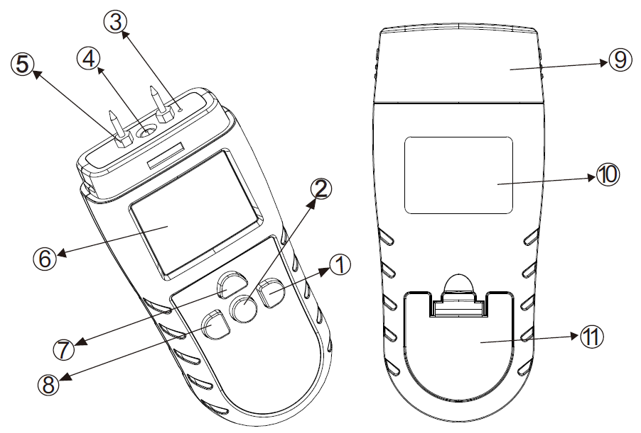
- LED ON/OFF button
- Power ON/OFF button
- Temperature sensor
- LED lighting Measurement
electrode pins
- LCD display
- MODE button
- HOLD button
- Protective cap
- Nameplate
- Battery cover

6. LCD DISPLAY DESCRIPTION
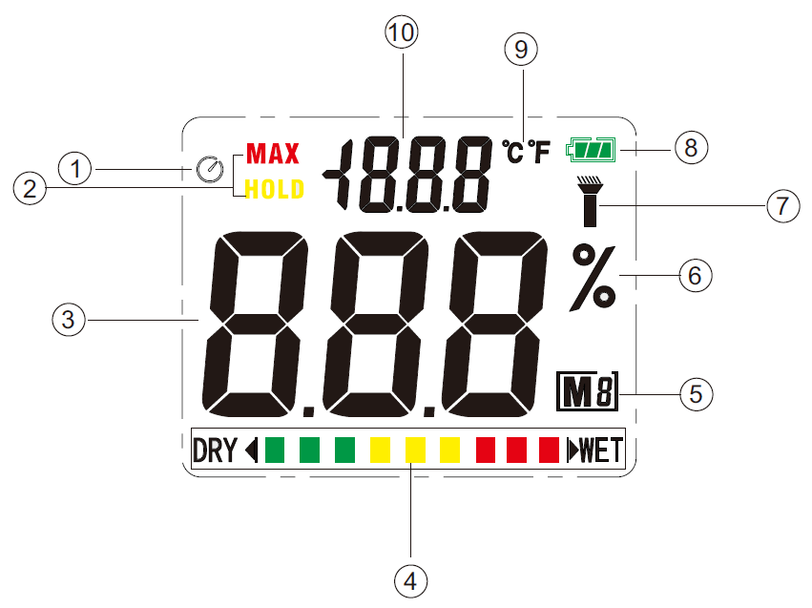

- Auto power Off icon
- MAX/HOLD icon
- Moisture level reading
- Tricolor LED bar graph
- Material mode icon
- Moisture unit
- Flashlight icon
- Battery level icon
- Temperature unit
- Temperature reading

7. OPERATING INSTRUCTIONS
  - Open the battery cover and install 5 *1.5V “LR44” cell battery according the polarity marks in the battery compartment.
  - Power on the meter, and then select the suitable measurement mode according to the object to be measured. Please refer to the material table in the last page.
  - Remove the protective cap to expose the electrode pins, carefully push the electrode pins as far as possible into the materials under test. Take several readings in several locations on the material for the best representation of the amount of moisture present. The measured values will be displayed on the LCD.
  - When the low battery icon””appears, replace the meter's battery.
8. BUTTON FUNCTIONS
8.1  Power On/Off button
During OFF mode, press this button to power on the meter.
During ON mode, press this button one time to turn on/off the auto power off function.
During ON mode, long press this button to turn off the meter.
  - 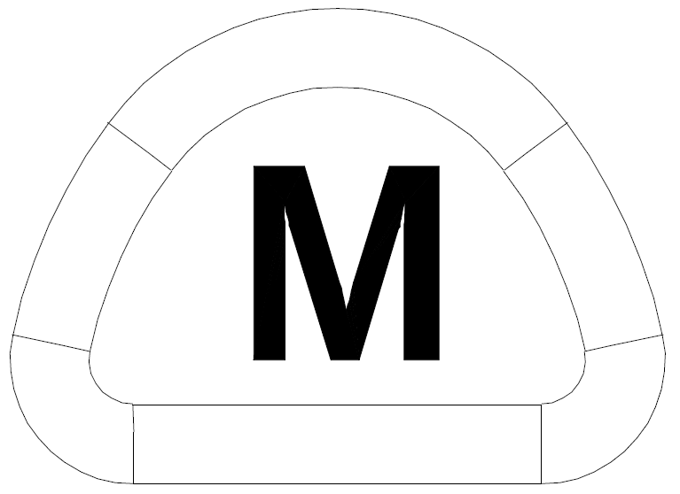 MODE Button
When the meter is on, press the MODE button to select the suitable measurement mode according to the object to be measured. (Please refer to the material table in the last page)
Long press this button for around 3 seconds to switch the temperatures ℃ or ℉.
  - 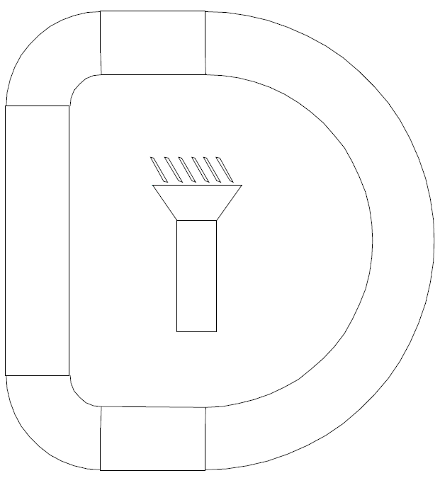 Flashlight ON/OFF
In measurement mode, press this button to turn on or turn off the flashlight.
  -  HOLD button
In measurement mode, press this button momentarily to enter to HOLD mode, the HOLD icon appears on the upper left LCD display. Press & Hold this button to enter into MAX mode, the MAX icon will appear on the upper left LCD display.

ATP INSTRUMENTATION LTD
WWW.ATP-INSTRUMENTATION.CO.UK

Sales: 01530 566800 Technical and Calibration: 05130 566804
Unit 22 Tournament Way,
Ashby De-La-Zouch,
Leicestershire,
LE65 2UU

