VANE ANEMOMETER
MT-905V
INSTRUCTION MANUAL

1. SAFETY
Read the following safety information carefully before attempting to operate or service the meter.
use the meter only as specified in this manual; otherwise, the protection provided by the meter may be impaired.
- Environment conditions:
Altitude lower than 2000 meters
RH≤90%（Non-Condensation）
Operating temperature: -20~60°C/-4~140°F
- Maintenance
Repairs or servicing not covered in this manual should only be performed by qualified personnel.
Wipe the unit with a dry soft cloth. do not use abrasives or solvents on this instrument.

Complies with EMC
2. GENERAL DESCRIPTION
This anemometer is designed with cups of wind wheel. it can more accurately and quickly sense the running speed of the wind and is not affected by the wind direction. The reading of wind speed, wind temperature and wind grade is displayed on the LCD screen. The product is mainly used in quality control, health prevention and control, wind speed and temperature measurement of various weather environments, such as building engineering, factories, schools, offices, air conditioning, etc.
- SPECIFICATIONS
Range | Resolution | Accuracy
0.7 ~ 30 m/s | ﹤20: 0.1 ﹥20: 1 | ± (4% +2 digit)
2.5 ~ 105 Km/h | ﹤20: 0.1 ﹥20: 1 | ± (4% +2 digit)
1.5 ~ 67.0 MPH | ﹤20: 0.1 ﹥20: 1 | ± (4% +2 digit)
1.3 ~ 58.3 knots | ﹤20: 0.1 ﹥20: 1 | ± (4% +2 digit)
-20°C~ 5°C  /-4°F～122°F | 0.1 | ±1.5°C (±2.7℉)
- Display: 3 digits LCD display
- Sampling time: one time per second
- MAX/AVG
- Measurement units: m/s, Km/h, Knots, Mph
- Auto power off: the meter will automatically power off after approx. 15 minutes of inactivity
- Power supply: 9V battery
- Battery life: at least 30 hours
- Operating conditions: -20~60°C/-4~140°F,
- 10%RH~90%RH
- Storage conditions: -20~60°C/-4~140°F,
- 10%RH~75%RH
- PANEL DESCRIPTION
- Vane sensor
- LCD display
- Power ON/OFF button
- MAX/AVG button
- Tripod mounting nut
- Battery compartment
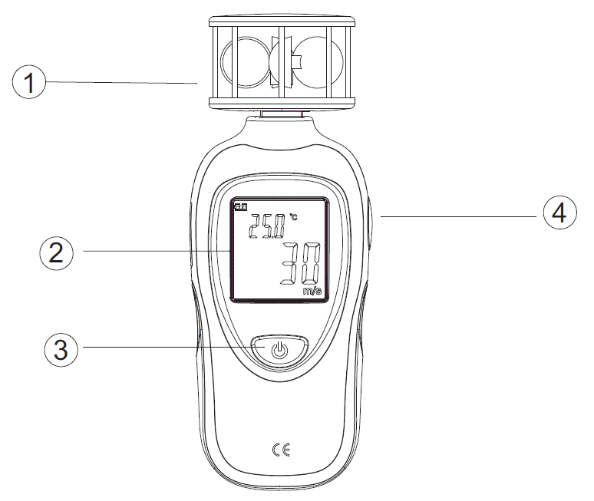
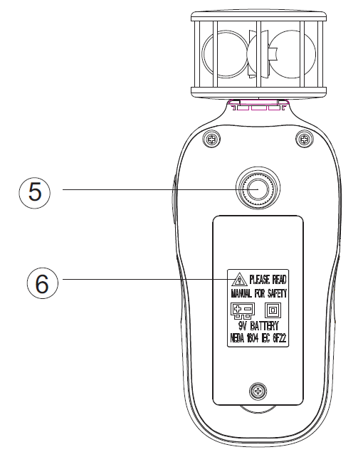

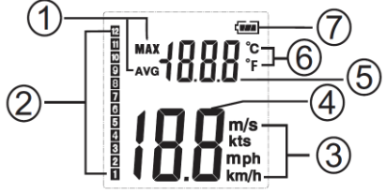
5. LCD DISPLAY DESCRIPTION

(1) Maximum/Average Symbol
(2) Wind speed grade
(3) Velocity unit
(4) Velocity readings
(5) Temperature readings
(6) Temperature units
(7) Battery symbol
- OPERATION INSTRUCTION
- Open battery cover and install a 9-volt battery in the battery compartment.
- Power ON: turn the meter on by pressing "Power ON/OFF" button for 3 seconds until the LCD is fully displayed, then release the button.
- Power OFF: turn the meter off by pressing and holding "Power ON/OFF" button for approx. 3 seconds until the LCD is switched off, then release the button
- Auto power off: the meter will automatically turn off after approx. 15 minutes of inactivity.
- Back-light：after turning the meter on, press any key to turn on the back-light, it will automatically turn off after approx. 30 seconds of inactivity.
- When the low battery icon "" appears, replace the meter's battery.
- MAX/AVG function: Press "MAX/AVG" button in turn to switch between MAX and AVG
- Temperature unit conversion; press the "MAX" button for 3 seconds, and the instrument will automatically switch the temperature unit
- Wind speed unit switching function; short press "power" button, to select wind speed units, m/s, Km/h, Knots, Mph in turn
- Overload Display: when the measuring temperature is lower than the range, "OL" displays on the LCD of deputy display area, when the temperature exceeds the range, the small display "OH" on the LCD of deputy display area. when the wind speed exceeds the range, the main display "OL" symbol.

7. NOTES
- This meter has already been calibrated before delivery. do not revise the calibration parameters without professional personnel and device. The recommended calibration period is one year.
- Repairs or servicing not covered in this manual should only be performed by qualified personnel.
- Do not use it in the area with high temperature of humidity.
- Wipe the unit with a dry soft cloth. do not use abrasives or solvents on this instrument.
- Remove the battery when the meter is to be stored for long periods of time to avoid battery leakage.

8. ACCESSORIES
- User's manual
- 9V battery


ATP INSTRUMENTATION LTD
THE ONE STOP INSTRUMENT SHOP

WWW.ATP-INSTRUMENTATION.CO.UK

Sales: 01530 566800
Technical and Calibration: 05130 566804

Sales: sales@atp-instruments.co.uk
Technical Support: technical@atp-instruments.co.uk
Calibration: calibration@atp-instruments.co.uk

Unit 22 Tournament Way,
Ashby De-La-Zouch,
Leicestershire,
LE65 2UU

